Phase III: Software Design and Modeling

1. Software Architecture
System Architecture
Urban Issue Tracker — System Architecture
The system follows a client-server architecture. The React frontend communicates with the Flask backend through a REST API via a shared api.js HTTP client. The backend handles all business logic, enforces role-based access, and reads/writes from PostgreSQL.

1. Citizen Reports an Issue
• Citizen fills out the report form on the React frontend (SubmitReport component)
• Request goes to the Flask backend (routes/reports.py)
• Backend checks JWT token via utils/authz.py to confirm the user is authenticated
• Backend validates the report data and writes a new row to the reports table in PostgreSQL
• Backend triggers a notification entry in the notifications table
• Frontend confirms submission and redirects the citizen to MyReports
2. Citizen Views Their Reports / Public Map
• Citizen opens MyReports or the PublicTracking/Map page (Leaflet.js renders the map)
• Request goes to routes/reports.py
• Backend queries the reports table filtered by the citizen’s user ID (or all public reports for the map)
• Backend sends the report list with statuses back to the frontend
• Frontend displays reports with status badges (StatusBadge component)
3. Staff Reviews and Updates a Report
• Staff member logs into the staff dashboard (React frontend)
• Frontend requests all reports from routes/reports.py
• Backend checks JWT token and confirms the role is staff via utils/authz.py
• Backend queries the reports table and returns all reports
• Staff selects a report and updates the status (e.g. In Progress → Resolved)
• Backend validates the status transition (lifecycle rules in routes/reports.py), checks SLA deadlines via utils/reporting.py, updates the reports table, and writes a new notification to the notifications table
• Frontend refreshes the dashboard with the updated status
4. Admin Manages Staff Accounts
• Admin logs in and opens the admin panel (React frontend, built by Stin)
• Frontend requests staff data from routes/admin.py
• Backend checks JWT token and confirms the role is admin via utils/authz.py
• Backend queries the users table filtered by role = staff
• Admin can create, disable, or reset a staff account — backend writes the change to the users table
• Frontend confirms the update in the admin panel
5. Admin Views Analytics and Exports Data
• Admin opens the analytics section of the admin panel
• Frontend requests stats from routes/admin.py
• Backend queries the reports table (counts by status, category, date, etc.) and returns aggregated data
• Admin can export — backend generates a CSV or PDF and returns it for download
• Frontend displays charts and download links
6. Login / Logout (All Roles)
• User submits credentials on the Login page
• Request goes to routes/auth.py
• Backend queries the users table, verifies the hashed password using bcrypt, and issues a JWT token
• Token is stored client-side and attached to every subsequent request
• On logout, the token’s JTI (unique JWT ID) is added to the token_blocklist table so it can never be reused
• Every protected request is checked against the blocklist in utils/authz.py

Component Diagram (UML)

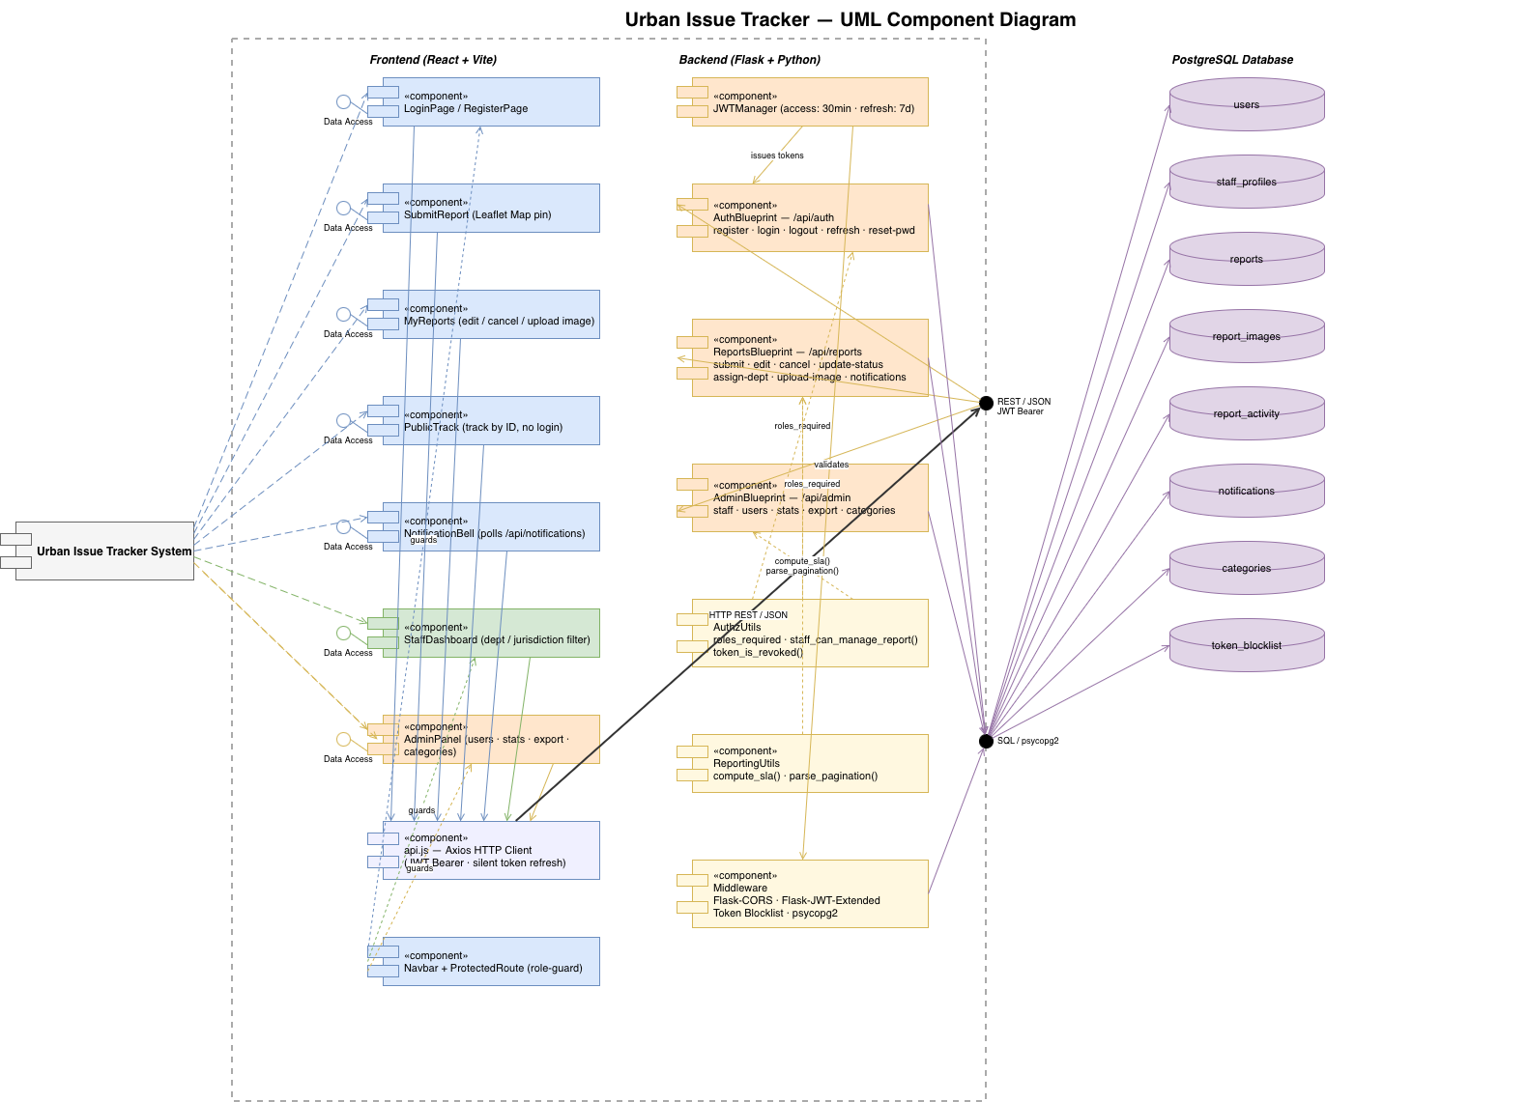

2. Detailed Design
Class Diagram

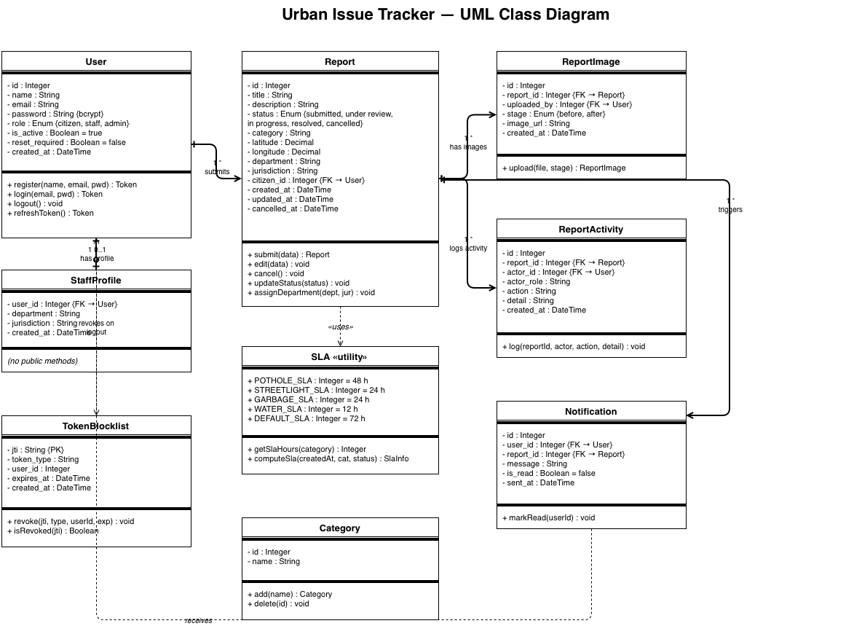

Sequence Diagrams

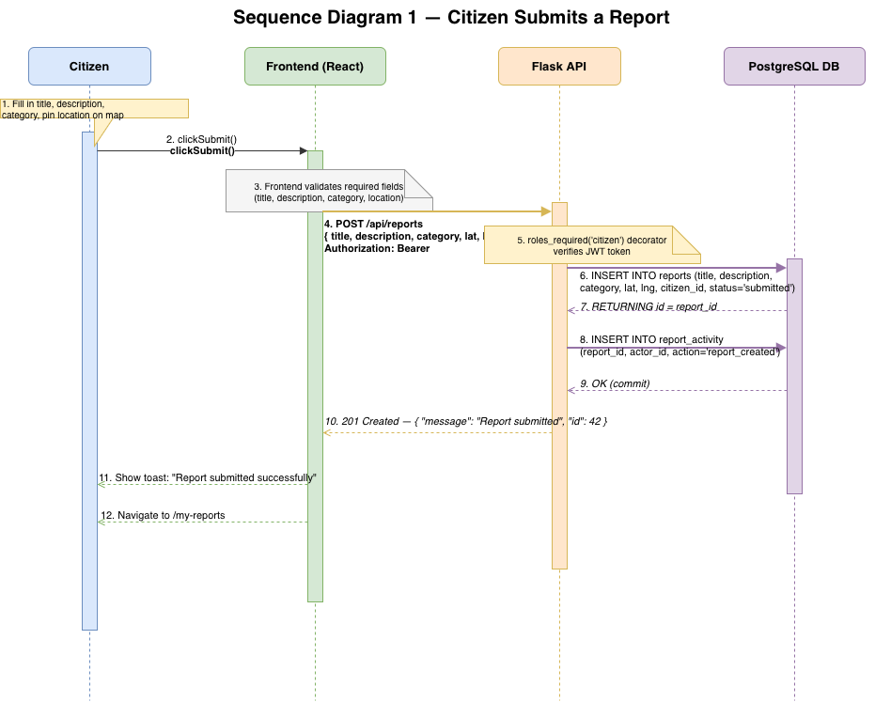

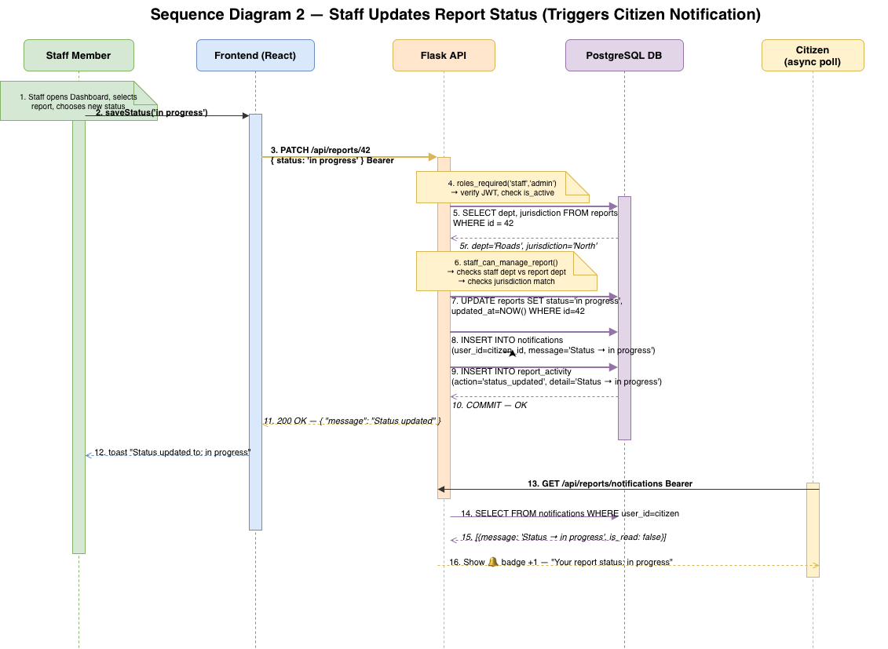

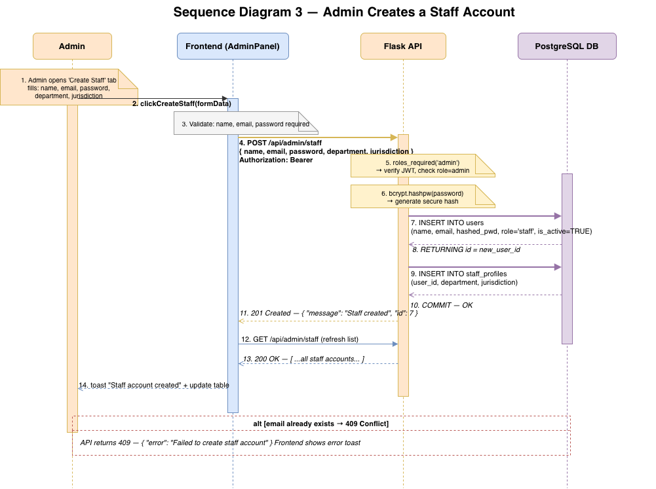

3. Modeling
Use Case Diagram

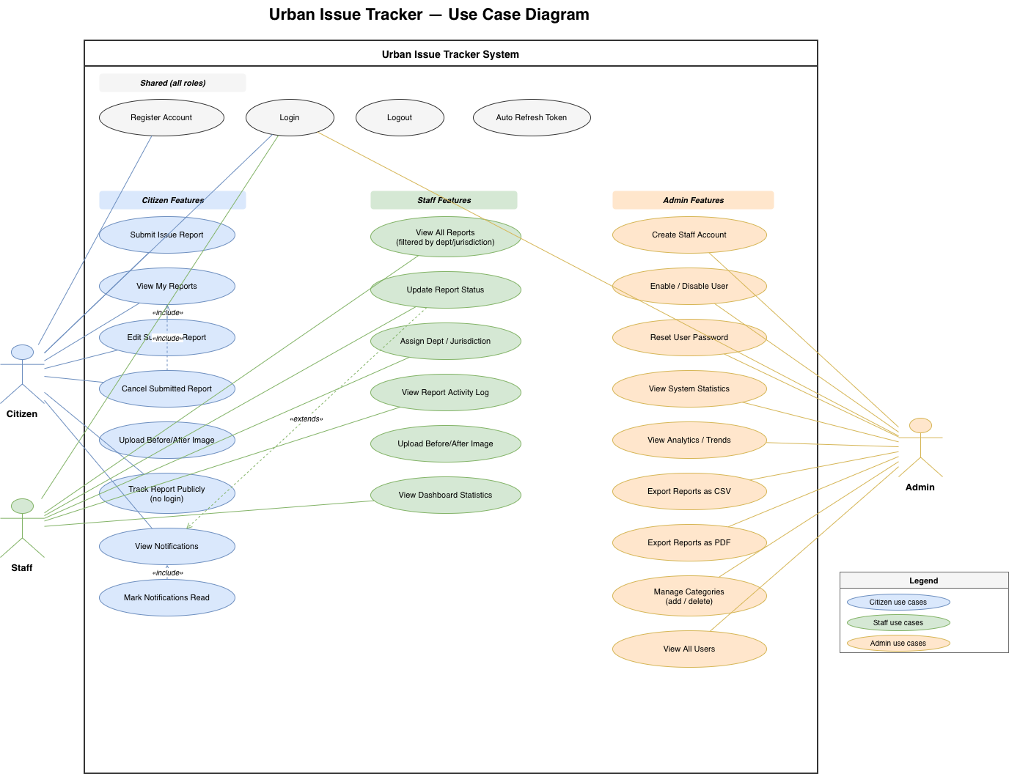

Activity Diagrams
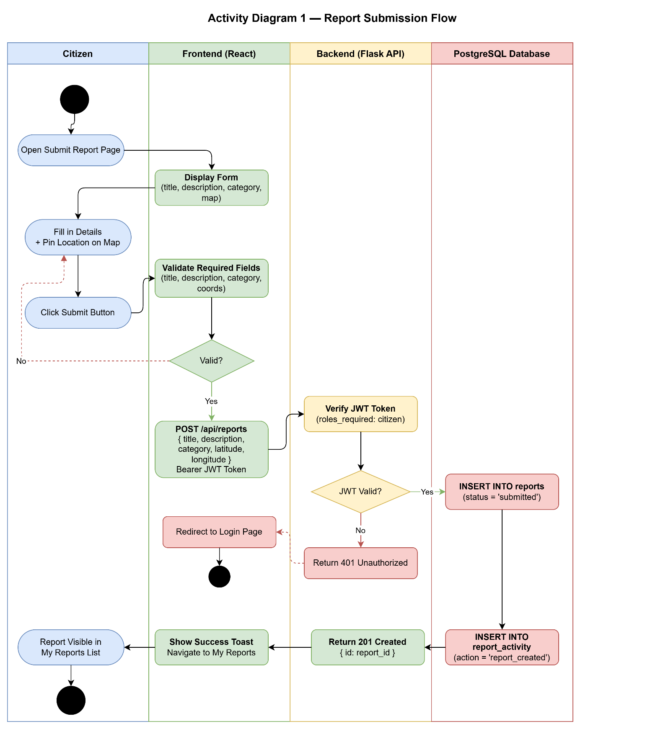

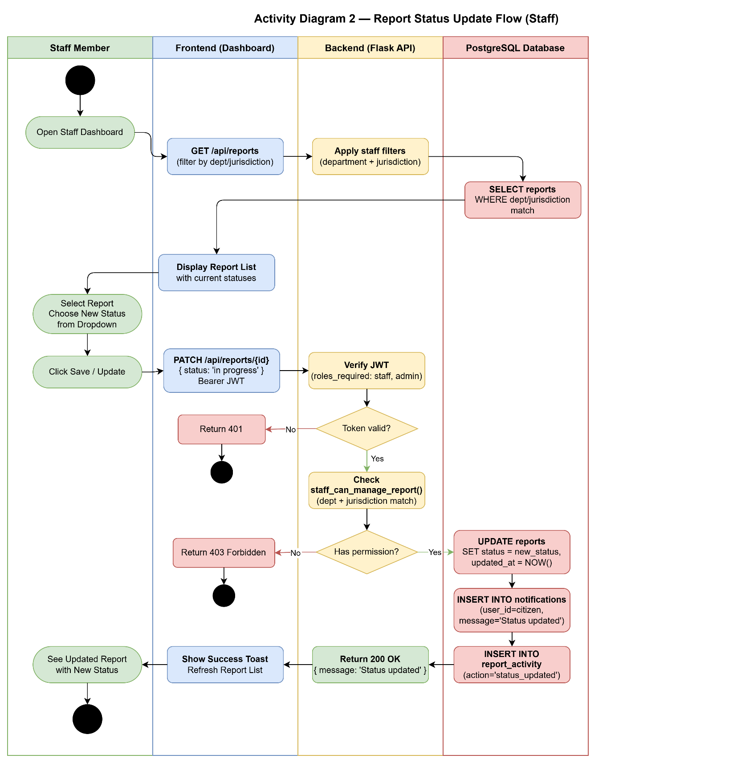

State Diagrams

